PRACTICAL 9 : Light, Humidity & Temperature Monitoring

Aim : To measure and display light intensity, humidity and temperature using respective sensors.

Overview :
This project integrates multiple sensors to measure light intensity, humidity and temperature. The collected data is displayed on an output device. It introduces multi-sensor interfacing and demonstrates how environmental monitoring can be implemented in IoT applications.

Materials Required :
- Arduino Uno R3
- 250 kΩ Potentiometer
- Temperature Sensor (TMP36)
- Ambient Light Sensor (Phototransistor)
- 3 x 1 kΩ Resistor
- Wifi Module (ESP8266)
- Breadboard Small
- Jumper Wires
- Arduino IDE (Installed on your Computer)

Circuit Connection and Steps :
- Powering Components : Connect the VCC of all sensors and the ESP8266 to 5V, except the ESP8266 (VCC & CH_PD → 3.3V). Ensure all GND pins are connected to a common ground.
- Sensor Connections :
  - The LM35 temperature sensor outputs data from its OUT pin to A0 of the Arduino.
  - The humidity sensor (potentiometer) has its middle pin connected to A1 for analog readings.
  - The LDR (light sensor) connects one leg to A2, the other to 5V, with a 10kΩ pull-down resistor to GND for stability.
- ESP8266 Communication :
  - Connect the ESP8266 TX to Arduino RX through a level shifter for proper voltage handling.
  - Connect the ESP8266 RX to Arduino TX directly.
  - Pull CH_PD high by connecting it to 3.3V to enable the module.

Circuit Diagram :
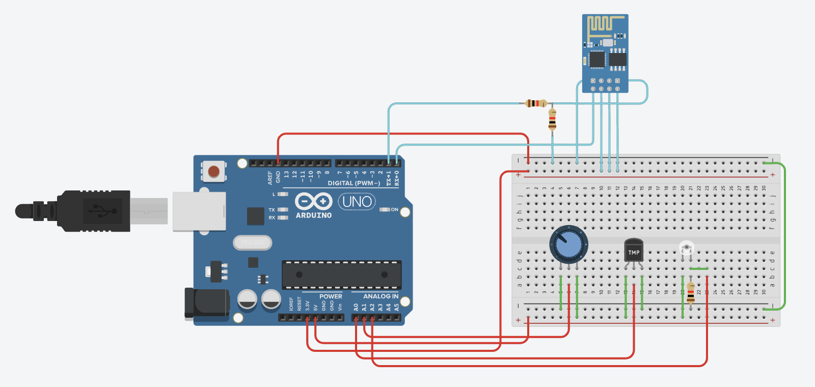
Schematic Diagram :
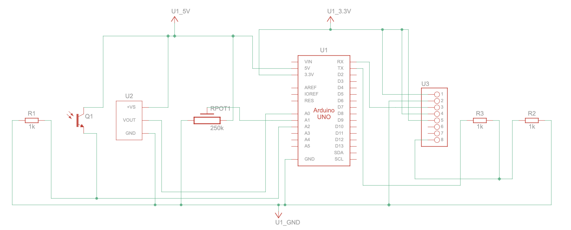

Code :
// WiFi Credentials
String ssid = "Simulator Wifi";
String password = "";
// ThingSpeak API Configuration
String host = "api.thingspeak.com";
const int httpPort = 80;
String apiKey = "YE76IRAW2UVM7LI5";
String endpoint = "/update?api_key=" + apiKey;
// Sensor Pin Configuration
const int tempPin = A0;
const int humidityPin = A1;
const int lightPin = A2;
void setup() {
Serial.begin(115200);
Serial.println("AT");
delay(500);
// Connect to WiFi
Serial.println("AT+CWJAP=\"" + ssid + "\",\"" + password + "\"");
delay(500);
// Establish TCP Connection
Serial.println("AT+CIPSTART=\"TCP\",\"" + host + "\"," + String(httpPort));
delay(500);
}
void loop() {
// Read sensor data
float temperature = ((analogRead(tempPin) * 0.0048828125) - 0.5) * 100;
float humidity = map(analogRead(humidityPin), 0, 1023, 0, 100);
float lightIntensity = map(analogRead(lightPin), 0, 471, 0, 100);
// Construct HTTP GET request
String httpRequest = "GET " + endpoint + "&field1=" + String(lightIntensity) +
"&field2=" + String(temperature) + "&field3=" + String(humidity) +
" HTTP/1.1\r\nHOST: " + host + "\r\n";

// Send data to ThingSpeak
Serial.println("AT+CIPSEND=" + String(httpRequest.length()));
delay(500);
Serial.println(httpRequest);
delay(1000);
}
Results :
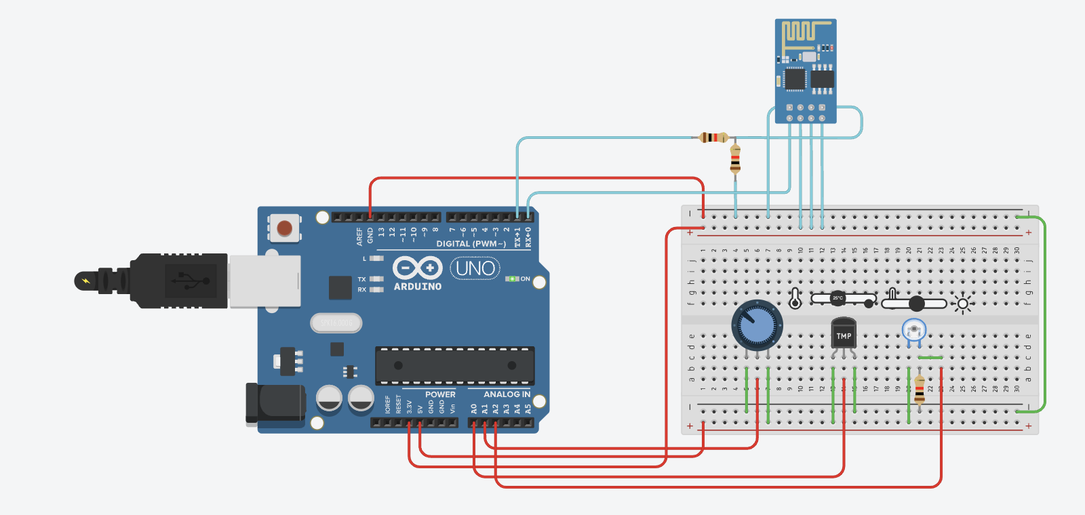

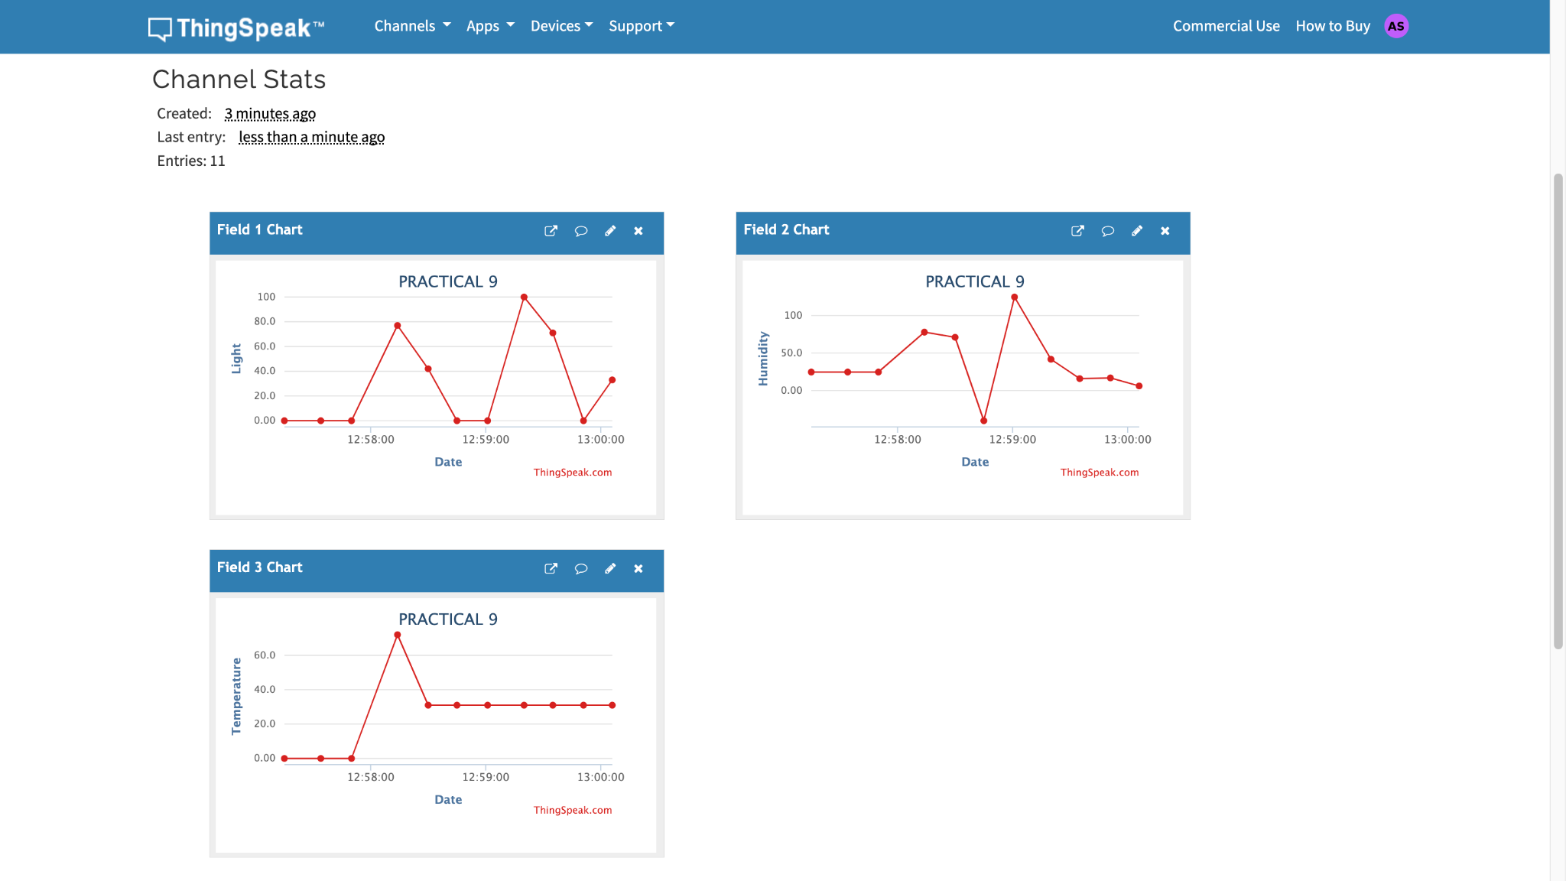

Conclusion :
The multi-sensor project successfully measures light intensity, humidity and temperature, showcasing the integration of multiple sensors with Arduino. It emphasizes real-time environmental data collection, which is crucial for applications in smart agriculture, weather monitoring and automated control systems.

